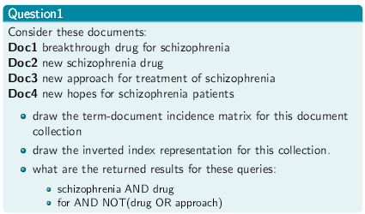
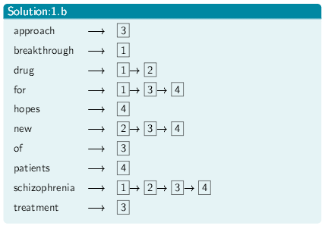
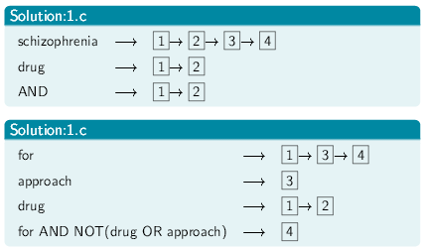
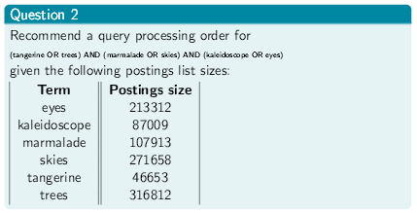
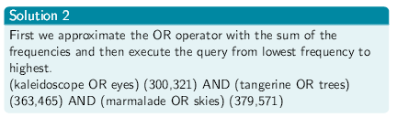

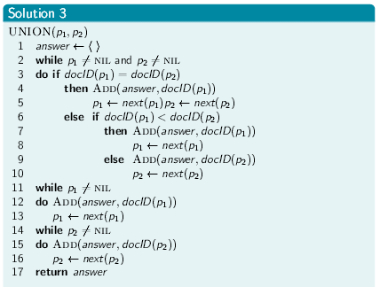
In a Boolean retrieval system, stemming never lowers precision?
- False. Stemming can increase the retrieved set without increasing the number of relevant documents.

In a Boolean retrieval system, stemming never lowers recall?
- True. Stemming can only increase the retrieved set, which means increased or unchanged recall.

Stemming increase the size of the vocabulary?
- False. Stemming decreases the size of the vocabulary.

Stemming should be invoked at indexing time but not while processing a query?
- False. The same processing should be applied to documents and queries to ensure matching terms.

Give an example of a sentence that falsely matches the wildcard query mor*ng if the search were to simply use a conjunction of bigrams.


Levenshtein Matrix Edit Distance

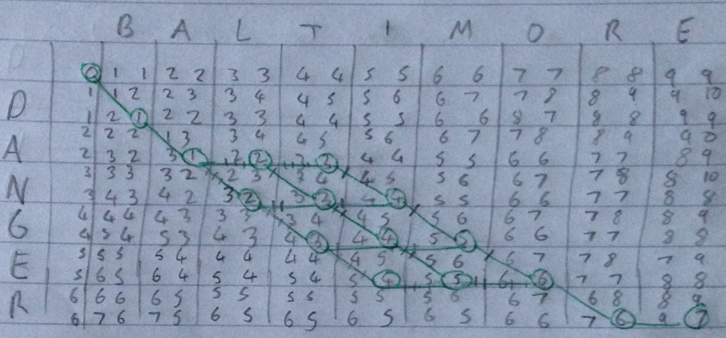


Compute Levenshtein distance matrix for OSLO – SNOW

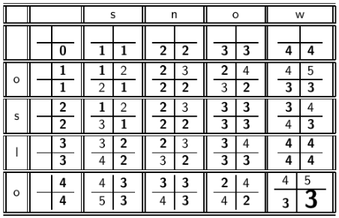

Compute Levenshtein distance matrix for do – redo

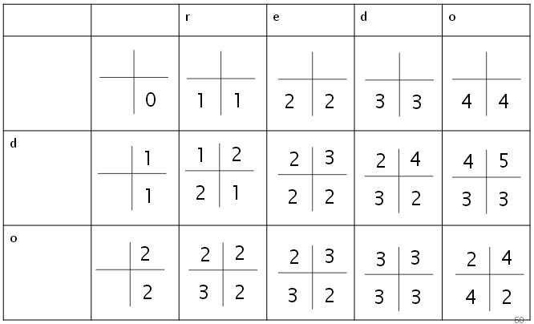
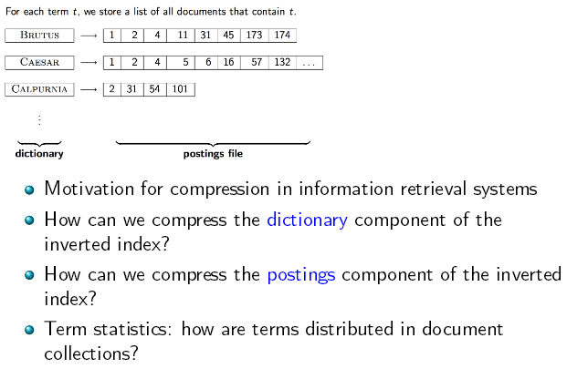
Compute Vocabulary Size M

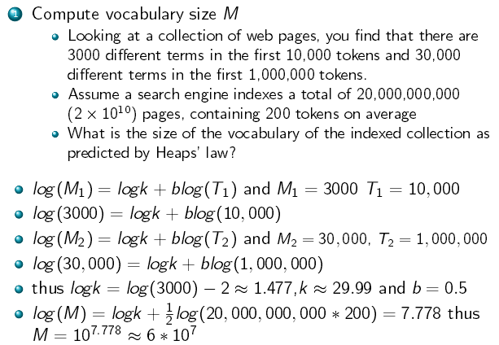

Dictonary Compression



Gamma Code

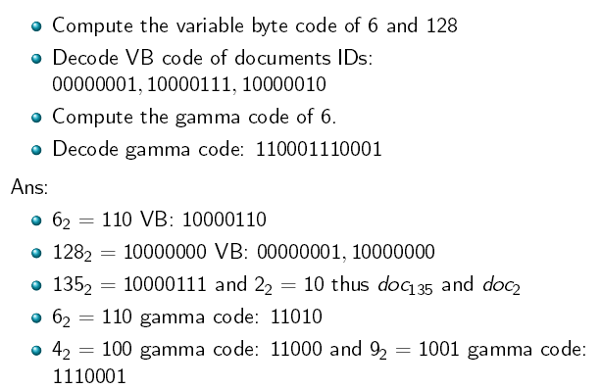

Ranked Retrieval in the Vector Space Model

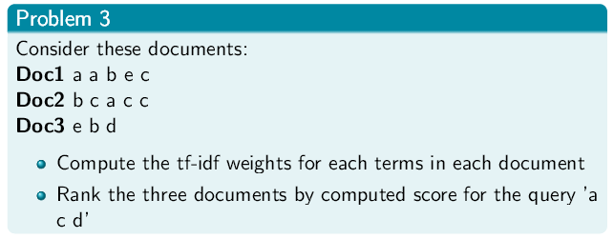

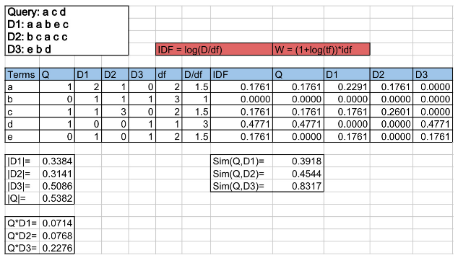

Assessing Relevance

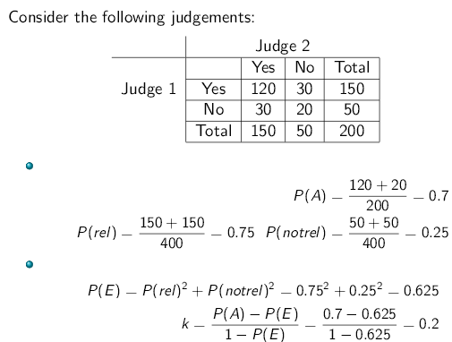

Assessing Relevance Exercise

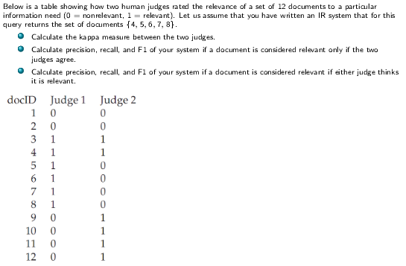

Solution

